

2022 iGEM InterLab study

# Multicolor fluorescence per particle calibration protocol

Plate readers report fluorescence values in arbitrary units that vary widely from instrument to instrument. Therefore, absolute fluorescence values cannot be directly compared from one instrument to another. In order to compare fluorescence output of biological devices, it is necessary to create a standard fluorescence curve. This variant of the protocol uses two replicates of three colors of dye, plus beads. Adapted from

* [https://dx.doi.org/10.17504/protocols.io.bht7j6rn](https://dx.doi.org/10.17504/protocols.io.bht7j6r)
* <https://dx.doi.org/10.17504/protocols.io.6zrhf56>.

Protocol in short: You will use the three color calibrants and the silica nanoparticles to perform serial dilutions from a known initial concentration. First, you will put 200uL of each solution in the first columns of the plate, and then you will aspirate 100uL and drop them into corresponding well of the next column. After that you will mix very well by pipetting up and down three times, and then you will transfer again 100uL into the well in the next column. Repeting this until the 11th column and discarding those last 100uL. Finally you will fill all the wells to a total volume of 200uL with the either water of PBS when appropriate. This step ensures that we have the same volume in the wells for calibration and for the experiments.

Important note: For the calibration and your experiments you must use the same type of plates and the same volumes. You must also use the same settings (e.g., filters or excitation and emission wavelengths) for the calibration and for the experiment. If you do not use the same plates, volumes, and settings, the measurements will not be valid.

## Protocol Outputs:

* fluorescein and bead fluorescence measurements of calibration plate
* sulforhodamine 101 fluorescence measurements of calibration plate
* cascade blue fluorescence measurements of calibration plate
* absorbance measurements of calibration plate

## Protocol Materials:

* [Water, sterile-filtered, BioReagent, suitable for cell culture](https://identifiers.org/pubchem.substance:24901740)
* [NanoCym 950nm monodisperse silica nanoparticles](https://nanocym.com/wp-content/uploads/2018/07/NanoCym-All-Datasheets-.pdf)
* [Phosphate Buffered Saline](https://pubchem.ncbi.nlm.nih.gov/substance/329753341)
* [Fluorescein](https://pubchem.ncbi.nlm.nih.gov/substance/329753341)
* [Cascade Blue](https://pubchem.ncbi.nlm.nih.gov/substance/329753341)
* [Sulforhodamine](https://pubchem.ncbi.nlm.nih.gov/substance/329753341)

## Protocol Steps:

1. Provision the stock reagent container containing Fluorescein calibrant. This is a powder.
2. Provision the stock reagent container containing Sulforhodamine 101 calibrant. This is a powder.
3. Provision the stock reagent container containing Cascade blue calibrant. This is a powder.
4. Provision the stock reagent container containing NanoCym 950nm microspheres
5. Transfer 1.0mL of Phosphate Buffered Saline sample to stock reagent container Fluorescein calibrant. The reconstituted Fluorescein should have a final concentration of 10 uM in Phosphate Buffered Saline
6. Vortex Fluorescein calibrant
7. Transfer 1.0mL of Phosphate Buffered Saline sample to stock reagent container Sulforhodamine 101 calibrant. The reconstituted Sulforhodamine standard will have a final concentration of 2 uM in Phosphate Buffered Saline
8. Vortex Sulforhodamine 101 calibrant
9. Transfer 1.0mL of Water, sterile-filtered, BioReagent, suitable for cell culture sample to stock reagent container Cascade blue calibrant. The reconstituted Cascade Blue calibrant will have a final concentration of 10 uM in Water, sterile-filtered, BioReagent, suitable for cell culture.
10. Vortex Cascade blue calibrant
11. Transfer 1.0mL of Water, sterile-filtered, BioReagent, suitable for cell culture sample to stock reagent container NanoCym 950 nm microspheres. The resuspended NanoCym 950nm monodisperse silica nanoparticles will have a final concentration of 3e9 microspheres/mL in Water, sterile-filtered, BioReagent, suitable for cell culture.
12. Vortex NanoCym 950 nm microspheres
13. Provision a 96 well microplate to contain calibration plate
14. Transfer 100.0uL of Phosphate Buffered Saline sample to wells A12:D12 of 96 well microplate calibration plate. These are blanks.
15. Transfer 100.0uL of Water, sterile-filtered, BioReagent, suitable for cell culture sample to wells E12:H12 of 96 well microplate calibration plate. These are blanks.
16. Transfer 200.0uL of Fluorescein calibrant sample to wells A1 of 96 well microplate calibration plate.
17. Transfer 200.0uL of Fluorescein calibrant sample to wells B1 of 96 well microplate calibration plate.
18. Transfer 200.0uL of Sulforhodamine 101 calibrant sample to wells C1 of 96 well microplate calibration plate.
19. Transfer 200.0uL of Sulforhodamine 101 calibrant sample to wells D1 of 96 well microplate calibration plate.
20. Transfer 200.0uL of Cascade blue calibrant sample to wells E1 of 96 well microplate calibration plate.
21. Transfer 200.0uL of Cascade blue calibrant sample to wells F1 of 96 well microplate calibration plate.
22. Transfer 200.0uL of NanoCym 950nm microspheres sample to wells G1 of 96 well microplate calibration plate.
23. Transfer 200.0uL of NanoCym 950nm microspheres sample to wells H1 of 96 well microplate calibration plate.
24. Perform a series of 10 2-fold dilutions on Fluorescein calibrant using Phosphate Buffered Saline as diluent to a final volume of 200.0uL in wells A1:A11 of 96 well microplate calibration plate. For each transfer, pipette up and down 3X to ensure the dilution is mixed homogeneously.

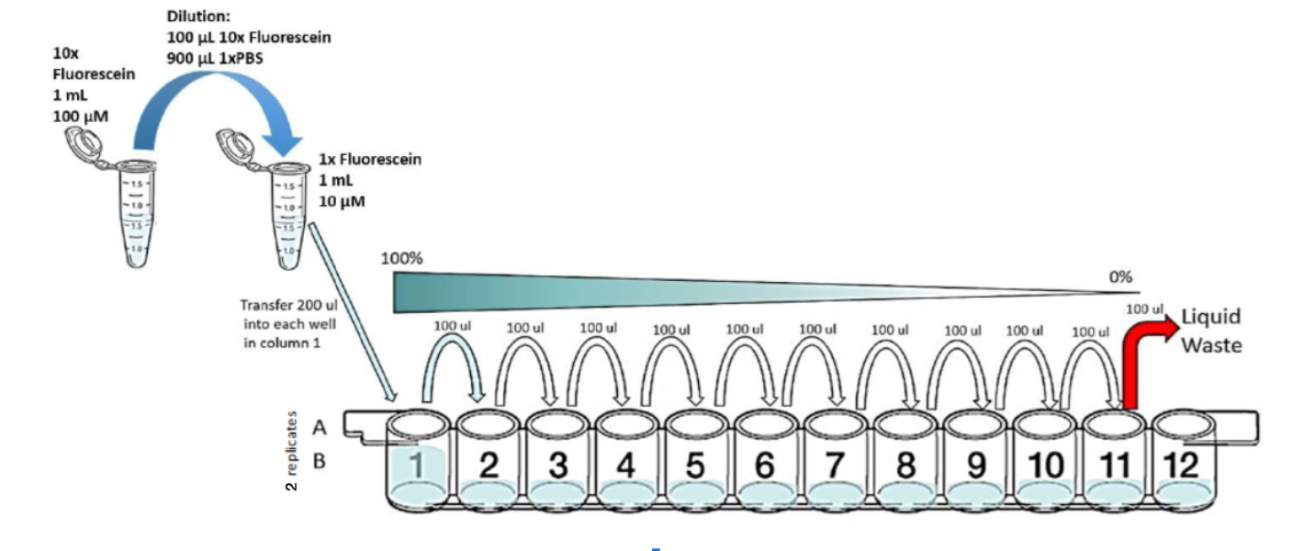

1. Perform a series of 10 2-fold dilutions on Fluorescein calibrant using Phosphate Buffered Saline as diluent to a final volume of 200.0uL in wells B1:B11 of 96 well microplate calibration plate. For each transfer, pipette up and down 3X to ensure the dilution is mixed homogeneously.
2. Perform a series of 10 2-fold dilutions on Sulforhodamine 101 calibrant using Phosphate Buffered Saline as diluent to a final volume of 200.0uL in wells C1:C11 of 96 well microplate calibration plate. For each transfer, pipette up and down 3X to ensure the dilution is mixed homogeneously.
3. Perform a series of 10 2-fold dilutions on Sulforhodamine 101 calibrant using Phosphate Buffered Saline as diluent to a final volume of 200.0uL in wells D1:D11 of 96 well microplate calibration plate. For each transfer, pipette up and down 3X to ensure the dilution is mixed homogeneously.
4. Perform a series of 10 2-fold dilutions on Cascade blue calibrant using Water, sterile-filtered, BioReagent, suitable for cell culture as diluent to a final volume of 200.0uL in wells E1:E11 of 96 well microplate calibration plate. For each transfer, pipette up and down 3X to ensure the dilution is mixed homogeneously.
5. Perform a series of 10 2-fold dilutions on Cascade blue calibrant using Water, sterile-filtered, BioReagent, suitable for cell culture as diluent to a final volume of 200.0uL in wells F1:F11 of 96 well microplate calibration plate. For each transfer, pipette up and down 3X to ensure the dilution is mixed homogeneously.
6. Perform a series of 10 2-fold dilutions on NanoCym 950nm microspheres using Water, sterile-filtered, BioReagent, suitable for cell culture as diluent to a final volume of 200.0uL in wells G1:G11 of 96 well microplate calibration plate. For each transfer, pipette up and down 3X to ensure the dilution is mixed homogeneously.
7. Perform a series of 10 2-fold dilutions on NanoCym 950nm microspheres using Water, sterile-filtered, BioReagent, suitable for cell culture as diluent to a final volume of 200.0uL in wells H1:H11 of 96 well microplate calibration plate. For each transfer, pipette up and down 3X to ensure the dilution is mixed homogeneously.
8. Discard 100.0uL from wells A11:H11 of 96 well microplate calibration plate. This step ensures that all wells contain an equivalent volume. Be sure to change pipette tips for every well to avoid cross-contamination
9. Transfer 100.0uL of Phosphate Buffered Saline sample to wells A1:D12 of 96 well microplate calibration plate. This will bring all wells to volume 200uL.
10. Transfer 100.0uL of Water, sterile-filtered, BioReagent, suitable for cell culture sample to wells E1:H12 of 96 well microplate calibration plate. This will bring all wells to volume 200uL.
11. Measure fluorescein and bead fluorescence of calibration plate with excitation wavelength of 488.0nm and emission filter of 530.0nm and 30.0nm bandpass.
12. Measure sulforhodamine 101 fluorescence of calibration plate with excitation wavelength of 561.0nm and emission filter of 610.0nm and 20.0nm bandpass.
13. Measure cascade blue fluorescence of calibration plate with excitation wavelength of 405.0nm and emission filter of 450.0nm and 50.0nm bandpass.
14. Measure absorbance of calibration plate at 600.0nm.
15. Import data for fluorescein and bead fluorescence measurements of calibration plate, sulforhodamine 101 fluorescence measurements of calibration plate, cascade blue fluorescence measurements of calibration plate, absorbance measurements of calibration plate into provided Excel file.

* Protocol version: 1.1b